Q1. Console "Hello Word" in document.ready function.
Ans: code:-
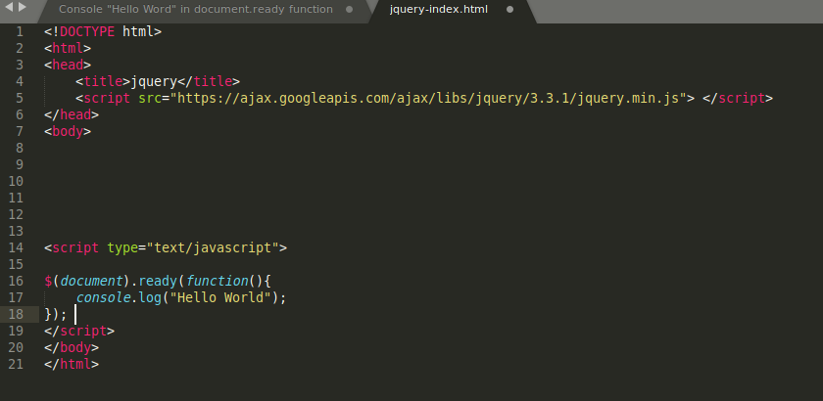
Output:-
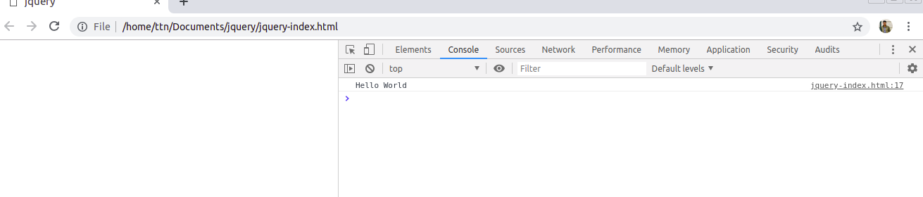

Q2. Select a ID name "#test" and add class "load" when DOM is loaded

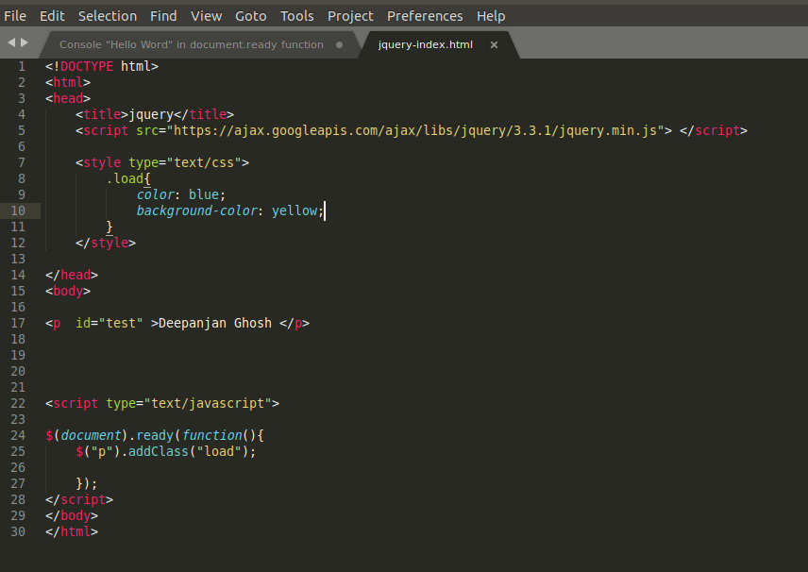
output:-
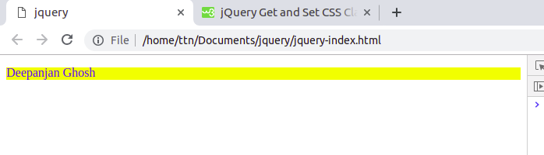

Q3. Change the color of element which class name end with "-new"
Ans: Code:-
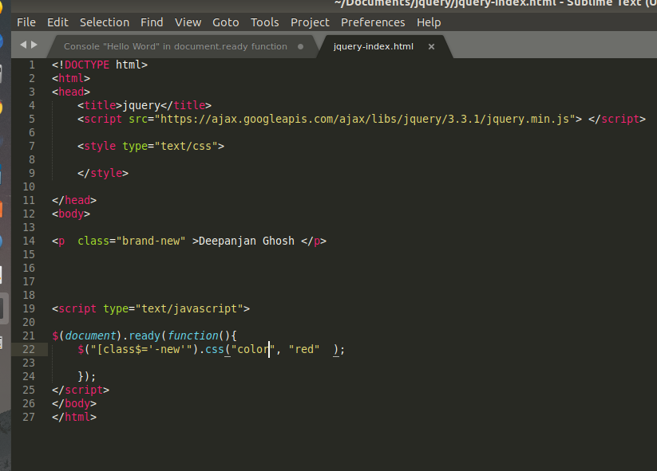
output:-
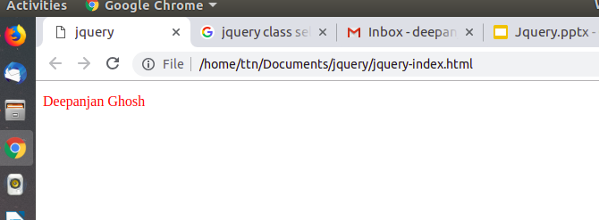

Q4. Disable submit button using jquery attr method
Ans: Code:-
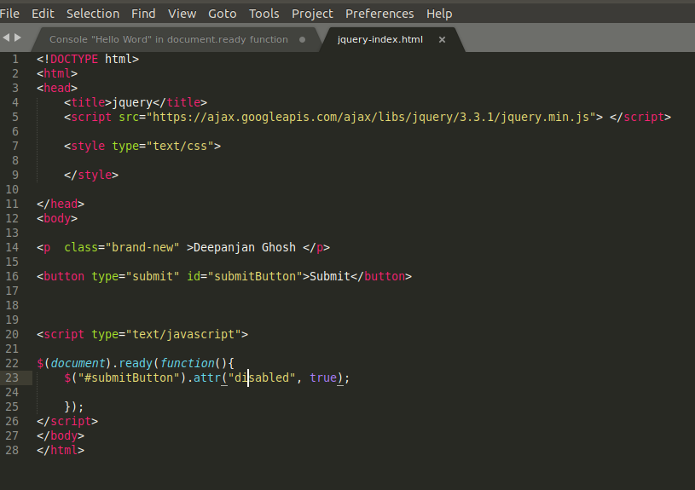
Output:-

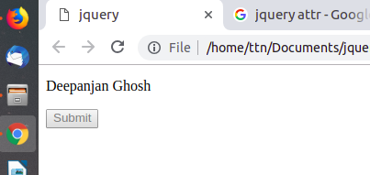

Q5. Change the font size of ".target" which has parent element with id name "#main"
Ans: Code:-
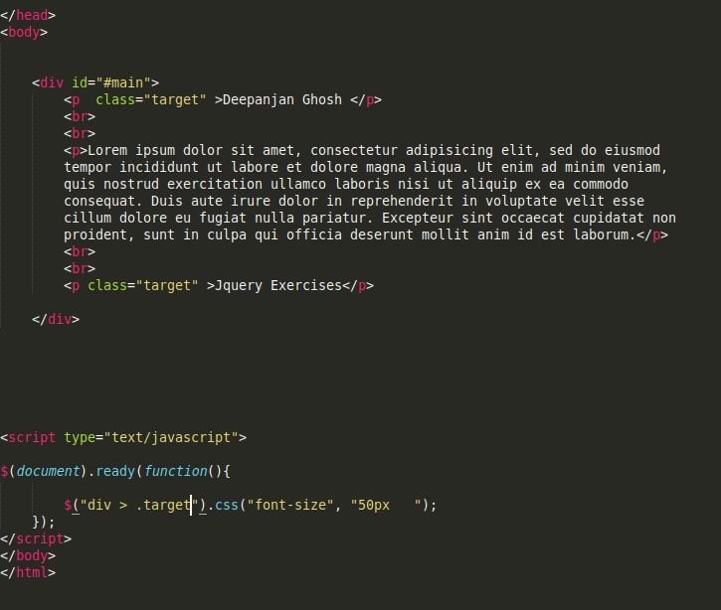
Output:
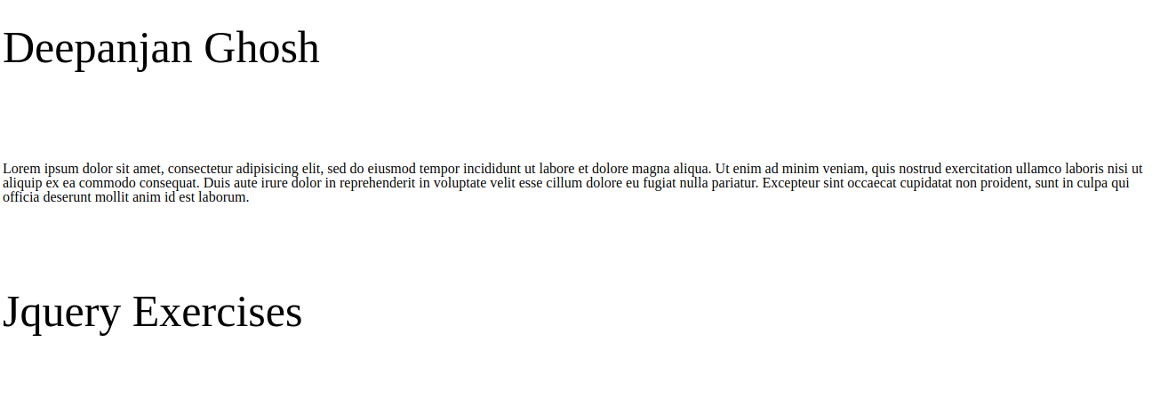

Q6 After page load change the HTML of div element with "p" element
Ans: Code:-
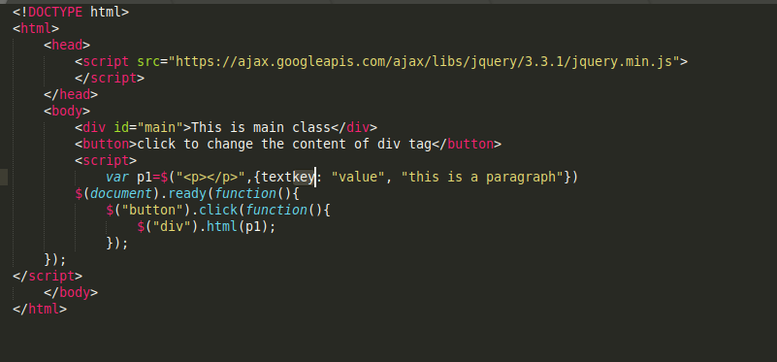

Output:

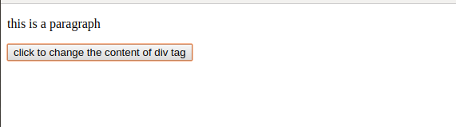

Q7. Bind a click function to an "click" element and append next "click" next to it.
Ans: Code:-
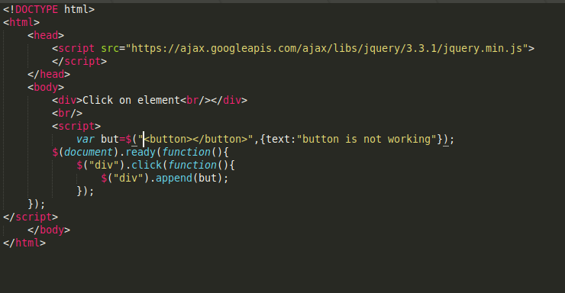
Output:
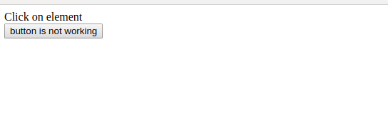

Q8: Click event not working on element which added dynamicly or via script, make it work using .on method
Ans: Code:
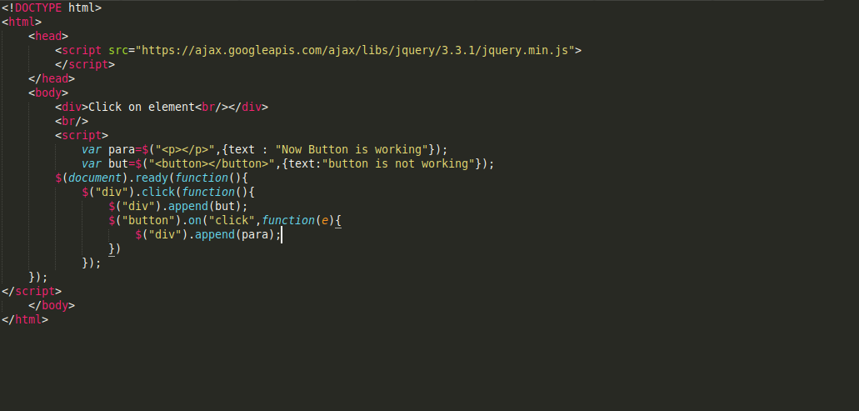

Output:

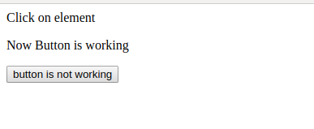

Q9. Get dropdown selected value on onchanage event and append in div container
ans. Code:-
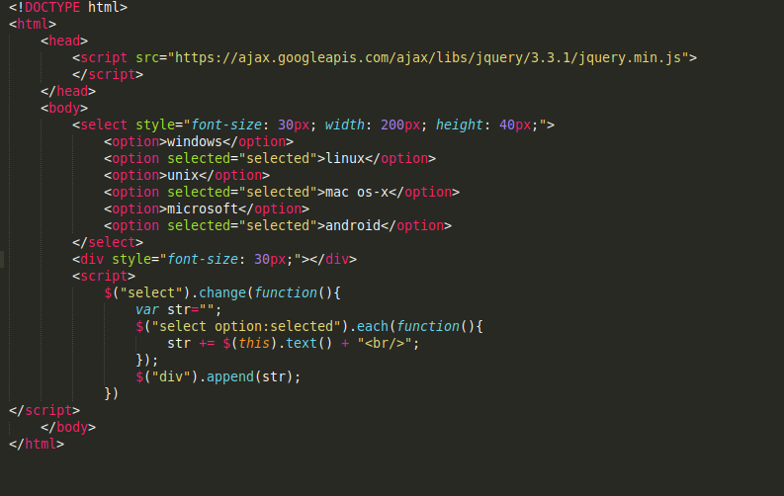

Output:-
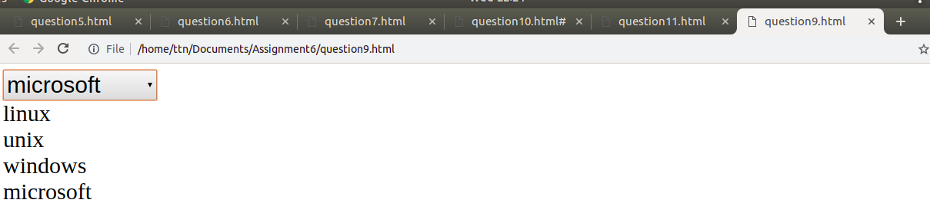

Q10. Create a dropdown menu using hover method in jquery
Ans: Code:-
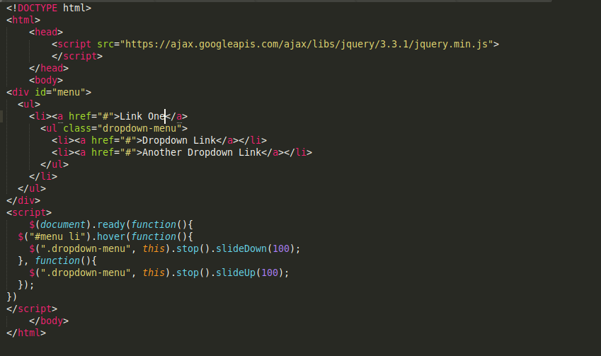

Output:-
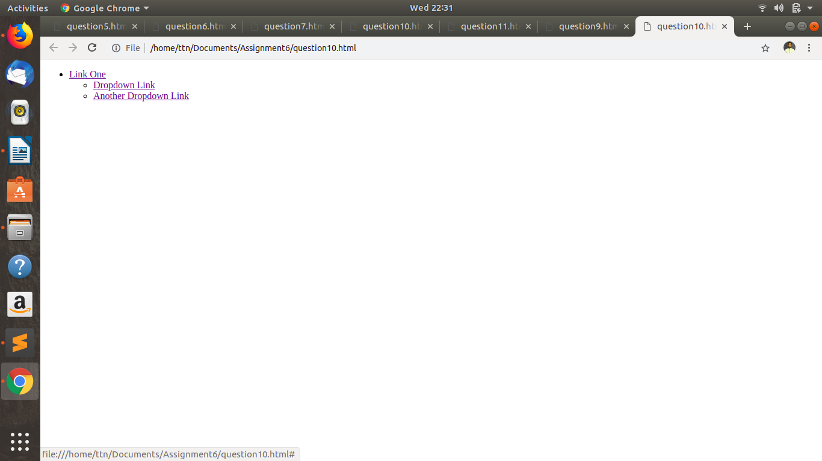

Q11. On clicking on “google” tag. It is taking us to google home page. Stop it from happening.
Ans: Code:-
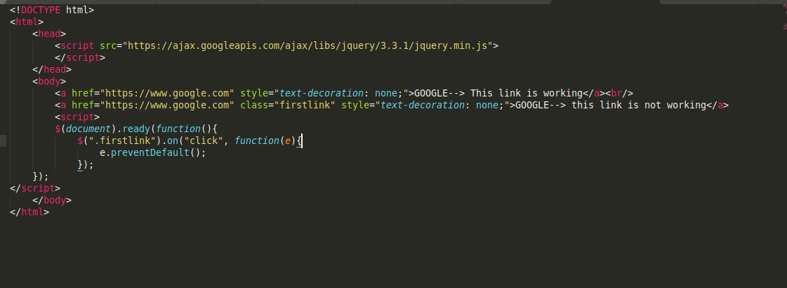

Output:

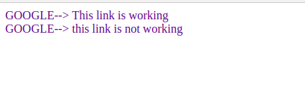

Q12. We have bind a click funtion to parent div but we want stop it from performing when user clicks on its child li
Ans: Code:-
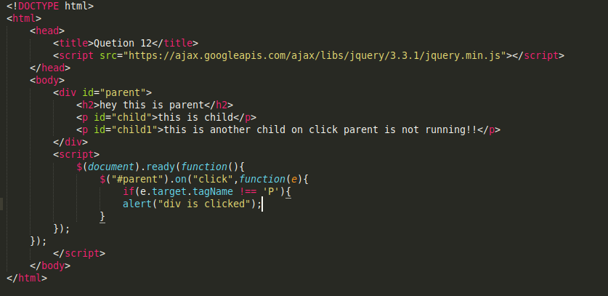

Ouput:
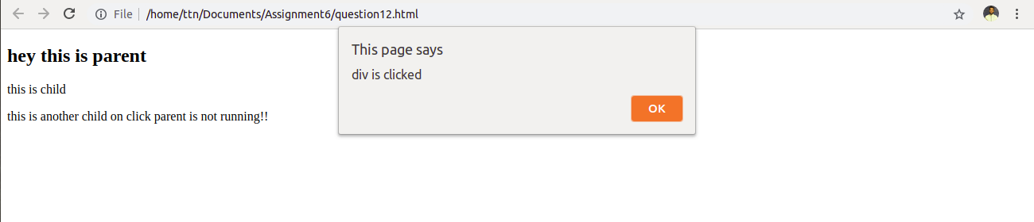

Q13. Get the max height of elements using jquery each method
Ans: Code:-
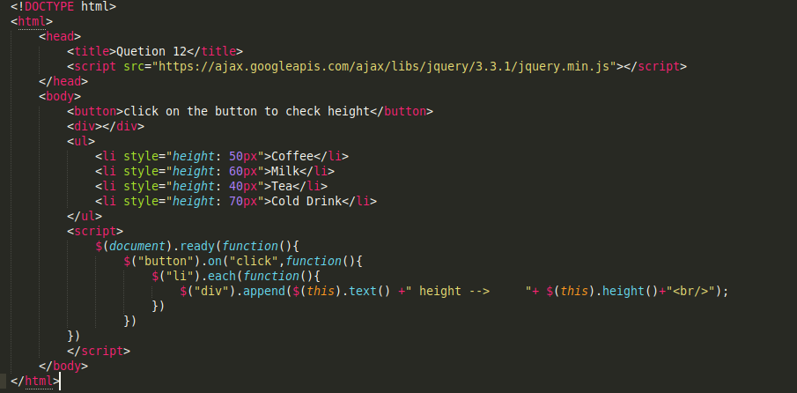

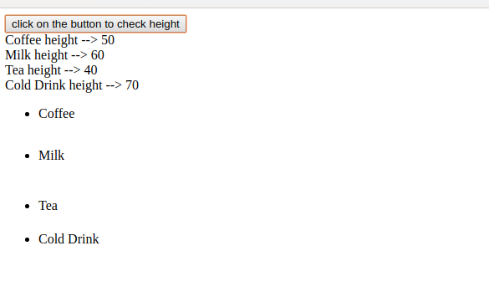
Output:-

Q14. Chagne color of every cell which has numberl larger than 10.
Ans: Code:-

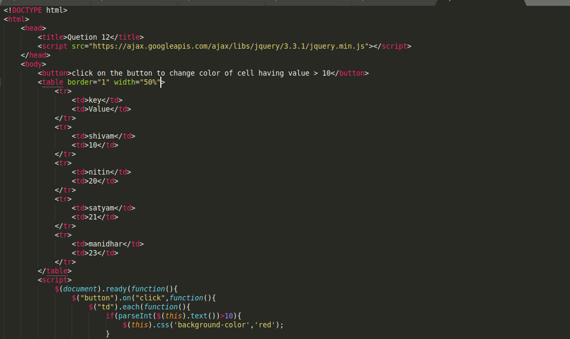

Output:-
